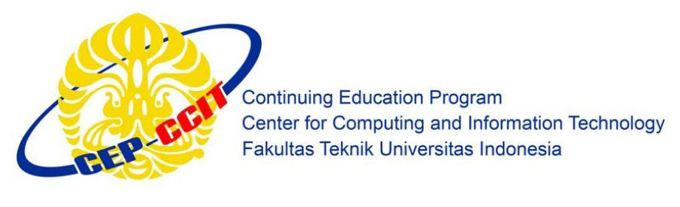**Information Search and Analysis Skills**

**(ISAS)**

**Implementation of MD5 Algorithm**

**Name : Muhammad Naufal P.P.**

**Ugi Ispoyo Widodo**

**Faculty : Riza Muhammad Nurman S.Kom**

**Semester : 4**

**Quarter : 2**

**Class : 4SC2**

**Gedung Pascasarjana Lt. 3 Fakultas Teknik Universitas Indonesia**

**Kampus Baru UI Depok 16424**